# LAND REGISTRATION SYSTEM USING BLOCKCHAIN TECHNOLOGY

INDEX

❖Abstract ❖ Advantages

❖Objective of project ❖ Project Flow

❖Problem Statement ❖ Hardware and Software Requirements

❖Scope & Motivation ❖ Architecture

❖Introduction ❖ Modules

❖Literature survey ❖ Umls

❖Existing Method ❖ Conclusion

❖Disadvantages ❖ future enhancement

❖Proposed method ❖ References

# ABSTRACT

The block chain technologies are spread in the form of a worldwide ledger that is available to everybody within the Block chain. Block chain technology has the potential to be extremely beneficial for storing vital information and data. The goal of this digital network is to create a completely secure database that is traceable and activated via protocols. Each user receives the prior in order to manage their assets. These assets are sustained by the act of singular truth. These block chain assets work together to create a block where users may register and occupy their base. This is due to the difficulty of maintaining a single truth. At times, these informative records will be incomplete and un-digitized, and the interaction will take place physically through voice or paper.

# PROBLEM STATEMENT

In modern asset registration systems, maintaining a universally accepted truth poses a challenge. Current databases lack a seamless, secure, and globally accessible framework. Vital information exists in fragmented forms, often incomplete and non-digital, requiring physical verification via voice or paper records. This discrepancy results in inconsistent asset management and unreliable data integrity. The absence of a unified, traceable system hinders efficient asset registration processes. This problem necessitates the integration of blockchain technology to establish a robust, transparent, and universally accessible ledger for accurate and secure asset registration.

**OBJECTIVE OF THE PROJECT:**

The objective of "Asset Registration Using Blockchain" is to leverage blockchain's distributed ledger technology to establish a secure, transparent, and immutable system for registering and managing assets. This aims to streamline asset ownership, ensuring accuracy, and reducing discrepancies through decentralized verification. By employing blockchain protocols, the objective is to create a universally accessible platform where users can confidently register assets, overcoming challenges of maintaining a singular truth. The goal is to enhance reliability, traceability, and accessibility while accommodating situations where data might exist in non-digital formats, enabling seamless integration of physical and digital records.

**Scope:** The scope of "Asset Registration Using Blockchain" encompasses establishing a robust, decentralized system for registering and managing assets. It involves implementing blockchain technology to create a secure and universally accessible ledger. This scope includes protocols for asset management, ensuring data traceability, and enabling users to interact within this secure network. The system addresses challenges in maintaining a singular truth, accommodating both digitized and physical asset records. Its reach spans across diverse industries seeking transparent, secure, and reliable asset registration mechanisms leveraging blockchain's capabilities.

**Motivation:** Blockchain technology revolutionizes asset registration by creating an inclusive, secure, and universally accessible ledger. Its potential to safeguard crucial data inspires confidence in storing vital information. Through this digital network, a tamper-proof database is formed, traceable via established protocols. Users manage assets via cryptographic keys, ensuring singular truth and security. Despite challenges like incomplete records, blockchain's adaptability accommodates physical interactions, bridging gaps through voice or paper.

# INTRODUCTION

Block chain is an emerging platform for developing decentralised applications and data storage among the shared parties with all recorded transactions that have been executed through- out the process. each and every transaction in the public ledger is verified using consensus protocols involving majority of the participants of the system. as the new data is emerging blocks are created and encrypted using hashing algorithms. thus, the information entered once cannot be modified without consulting a legal administrator. block chain allows one to create a ledger of events, transactions and data, generated through various it processes with strong cryptographic guarantees, that is distributed and replicated across the network for tamper resistance, immutability and verifiability. it is a distributed digital ledger that is open, shared, transparent and highly secured which means all the transactions or records processed are immutable and verifiable. as the name indicates, block chain allows a block of data to grow as new blocks are appended to it, with each block containing transaction information stored in a specially designed data storage structure.

# LITERATURE SURVEY

|  |  |  |  |  |
| --- | --- | --- | --- | --- |
| **S**  **.**  **N**  **o** | **Journal Type with year** | **Authors** | **Title** | **Outcomes** |
| 1 | Journal June2018 | N.S.Tinu | A Survey on Blockchain Technology  Taxonomy, Consensus Algorithms and Applications | The Land registration system incorporating block chain using block chain provides features like registration of owner and land by uploading mandatory verified documents |
| 2 | Journal 2018 | J. Michael Graglia | Digitalization of Land Record. | use of proof of existence, proof of audit and proof of process for establishing permanent time stamped digital records is introduced to avoid visual manual |
| 3 | Journal 2018 | Yashwanth Madak | block chain application using Hyper ledger Fabric with Angular Frontend | We began to propound our idea of a block chain based land registration system as an alternative to the traditional one by taking various factors into account |
| 4 | Journal 2019 | Madakam, S | Land purchasing by seller by using the block chain | All changes are stored in the next block so that no user is unaware of the current state of any asset and all transactions are stored in a block chain with appropriate timestamps associated with them for strong auditability |

**EXISTING METHOD:**

Blockchain technology can be used to build a decentralised, secure, and tamper-proof asset registration system.These are just a few applications of blockchain technology for asset registration. The primary advantages of using blockchain for asset registration are increased transparency, security, efficiency, and reduced fraud risk.

**DISADVANTAGES:**

**1.Incomplete Records:** In some cases, records on the blockchain might be incomplete or un-digitized, especially when dealing with physical assets or legacy systems. This could lead to difficulties in accurately representing all assets within the blockchain network

.**2. Limited Interoperability:** Interoperability between different blockchain platforms and systems can be challenging. This could potentially create fragmented systems, making it difficult for different entities using separate blockchain networks to communicate and share asset data seamlessly.

**3. Scalability Concerns:** As the number of transactions and users on a blockchain network increases, scalability becomes a concern. The technology might face limitations in handling a large volume of transactions efficiently, leading to slower processing times and increased costs.

## PROPOSED SYSTEM

A proposed system for asset registration using blockchain involves a decentralized ledger accessible to all network participants, ensuring secure, transparent asset management. Smart contracts enable automatic asset transfers, eliminating intermediaries and enhancing efficiency. Immutable records ensure data integrity, while cryptographic security safeguards sensitive information. The system aims to streamline asset registration, leveraging blockchain's distributed nature for a tamper-resistant, accessible, and efficient registration process across various asset types.

**ADVANTAGES:**

**Transparency and Security:** Blockchain's decentralized nature ensures transparency and security by providing an immutable record of transactions, reducing fraud and unauthorized changes.

**Efficiency and Accuracy:** Asset registration through blockchain can streamline processes, reducing paperwork and human error, leading to more accurate and efficient asset management.

**Global Accessibility:** As a distributed ledger, blockchain allows for global accessibility to asset information, facilitating easier and faster cross-border transactions without the need for intermediaries.

## PROPOSED SYSTEM DIAGRAM

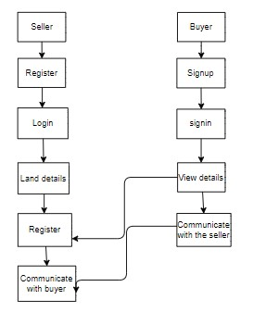

**SOFTWARE AND HARDWARE REQUIREMENTS:**

**SYSTEM SPECIFICATIONS:**

**H/W Specifications:**

1. Processor : I5/Intel Processor
2. RAM : 8GB (min)
3. Hard Disk : 128 GB

**S/W Specifications:**

* Operating System : Windows 10
* Front end react : React Js
* Technology/backend : Python
* IDE : VS code

## ARCHITECUTURE

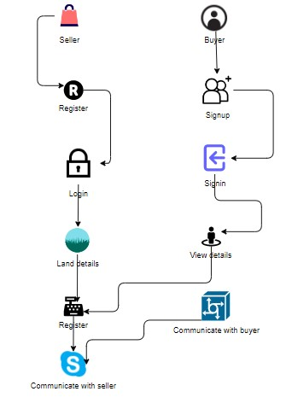

**MODULES:**

**BUYER:**

Register: Buyer will register to the page.

Login: The Buyer will login after the registration.

View the selling land details: After the login the buyer can view the details.

Communicate with the seller: Buyer can esay communicate with the buyer after the viewing the details.

**SELLER:**

Signup: Needs to signup the page.

SignIn: After signup seller needs to signing.

Add land details: Seller can add details of land.

View the buyer requests: After adding the details they can view.

Communicate with the buyer: Seller can communicate with buyer

**UML DIAGRAMS**

UML stands for Unified Modelling Language. UML is a standardized general-purpose modelling language in the field of object-oriented software engineering. The standard is managed, and was created by, the Object Management Group.

The goal is for UML to become a common language for creating models of object-oriented computer software. In its current form UML is comprised of two major components: a Meta-model and a notation. In the future, some form of method or process may also be added to; or associated with, UML.

The Unified Modelling Language is a standard language for specifying, Visualization, Constructing and documenting the artefacts of software system, as well as for business modelling and other non-software systems.

The UML represents a collection of best engineering practices that have proven successful in the modelling of large and complex systems.

The UML is a very important part of developing objects-oriented software and the software development process.

The UML uses mostly graphical notations to express the design of software projects.

**GOALS:**

The Primary goals in the design of the UML are as follows:

1. Provide users a ready-to-use, expressive visual modelling Language so that they can develop and exchange meaningful models.
2. Provide extendibility and specialization mechanisms to extend the core concepts.
3. Be independent of particular programming languages and development process.
4. Provide a formal basis for understanding the modelling language.
5. Encourage the growth of OO tools market.
6. Support higher level development concepts such as collaborations, frameworks, patterns and components.
7. Integrate best practices.

**USE CASE DIAGRAM**

* A use case diagram in the Unified Modeling Language (UML) is a type of behavioral diagram defined by and created from a Use-case analysis.
* Its purpose is to present a graphical overview of the functionality provided by a system in terms of actors, their goals (represented as use cases), and any dependencies between those use cases.
* The main purpose of a use case diagram is to show what system functions are performed for which actor. Roles of the actors in the system can be depicted. 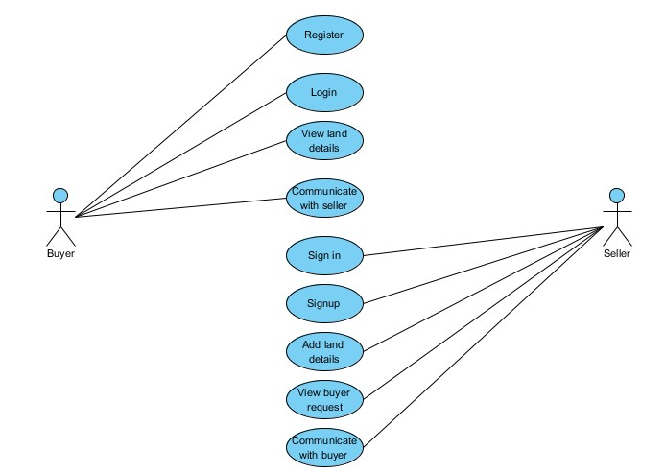

**CLASS DIAGRAM**

* In software engineering, a class diagram in the Unified Modeling Language (UML) is a type of static structure diagram that describes the structure of a system by showing the system's classes, their attributes, operations (or methods), and the relationships among the classes. It explains which class contains information

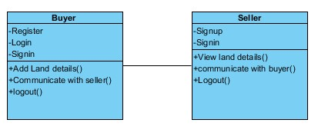

**SEQUENCE DIAGRAM**

* A sequence diagram in Unified Modeling Language (UML) is a kind of interaction diagram that shows how processes operate with one another and in what order.
* It is a construct of a Message Sequence Chart. Sequence diagrams are sometimes called event diagrams, event scenarios, and timing diagrams

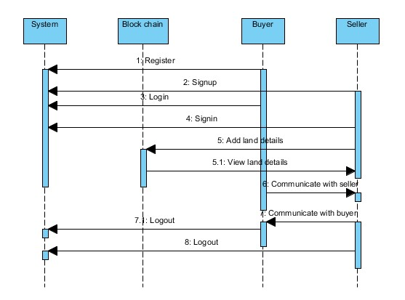

**COLLABORATION DIAGRAM:**

* In collaboration diagram the method call sequence is indicated by some numbering technique as shown below. The number indicates how the methods are called one after another. We have taken the same order management system to describe the collaboration diagram. The method calls are similar to that of a sequence diagram. But the difference is that the sequence diagram does not describe the object organization whereas the collaboration diagram shows the object organization.

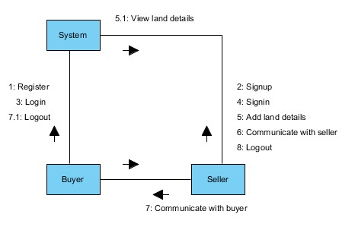

**DEPLOYMENT DIAGRAM**

* Deployment diagram represents the deployment view of a system. It is related to the component diagram. Because the components are deployed using the deployment diagrams. A deployment diagram consists of nodes. Nodes are nothing but physical hardware’s used to deploy the application.

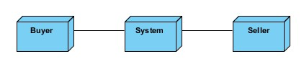

**ACTIVITY DIAGRAM:**

* Activity diagrams are graphical representations of workflows of stepwise activities and actions with support for choice, iteration and concurrency. In the Unified Modelling Language, activity diagrams can be used to describe the business and operational step-by-step workflows of components in a system. An activity diagram shows the overall flow of control. 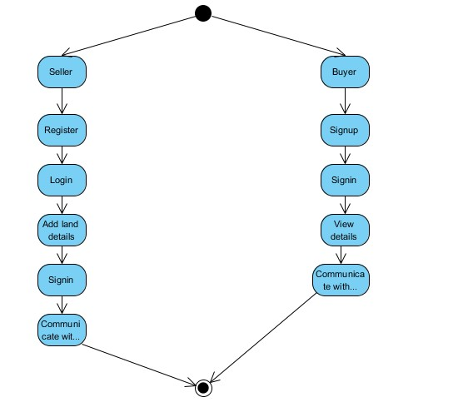

**COMPONENT DIAGRAM**:

* A component diagram, also known as a UML component diagram, describes the organization and wiring of the physical **c**omponents in a system. Component diagrams are often drawn to help model implementation details and double-check that every aspect of the system's required function is covered by planned development.

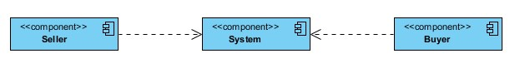

**ER DIAGRAM:**

* An Entity–relationship model (ER model) describes the structure of a database with the help of a diagram, which is known as Entity Relationship Diagram (ER Diagram). An ER model is a design or blueprint of a database that can later be implemented as a database. The main components of E-R model are: entity set and relationship set.
* An ER diagram shows the relationship among entity sets. An entity set is a group of similar entities and these entities can have attributes. In terms of DBMS, an entity is a table or attribute of a table in database, so by showing relationship among tables and their attributes, ER diagram shows the complete logical structure of a database. Let’s have a look at a simple ER diagram to understand this concept.

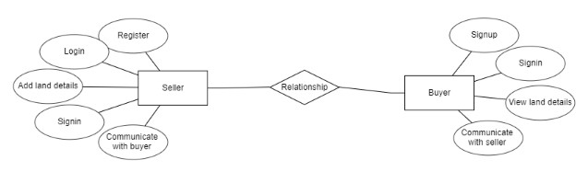

**DFD DIAGRAM:**

* A Data Flow Diagram (DFD) is a traditional way to visualize the information flows within a system. A neat and clear DFD can depict a good amount of the system requirements graphically. It can be manual, automated, or a combination of both. It shows how information enters and leaves the system, what changes the information and where information is stored. The purpose of a DFD is to show the scope and boundaries of a system as a whole. It may be used as a communications tool between a systems analyst and any person who plays a part in the system that acts as the starting point for redesigning a system.

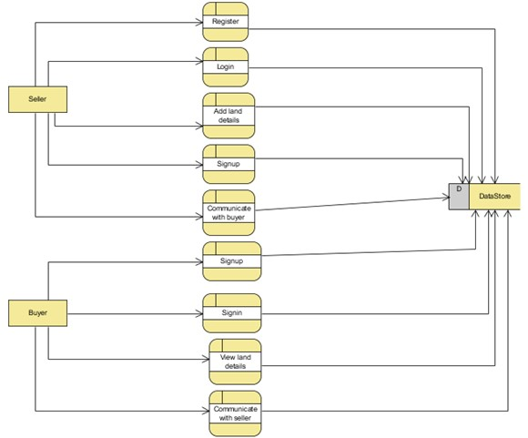

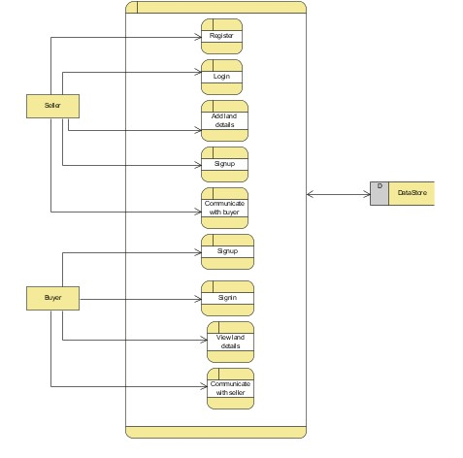

**CONCLUSION:**

In conclusion, an asset registration using block chain is the use of the block - chain is one of its most popular methods of storing things. It is a public digital database that cannot be altered once data has been entered. The Customary Land Scenario in India is one of the most deceptive processes in the country, and we would like to use block chain technology to combat it. In our systems, Hyperledger is used to leverage blockchain technology. A new system is created when all actions, such as purchasing and selling, are done in a more practical and trustworthy manner. This mechanism is now more secure and faster than before thanks to the use of smart contracts. If this type of mechanism is further developed and combined with relevant APIs, faster operations can be achieved. It would also result in a more efficient and comfortable system, which would benefit society in the long run.

**FUTURE ENHANCEMENT**

In the realm of asset registration using blockchain, future advancements could focus on improving interoperability between different blockchain networks, enhancing scalability to handle increased transaction volumes without compromising speed, and refining privacy measures to balance transparency and confidentiality. Innovations might also target energy-efficient consensus mechanisms to minimize environmental impact and develop smart contracts with more complex functionalities. Additionally, integrating AI algorithms for data verification and validation could further streamline and enhance the accuracy of asset registration processes within blockchain networks, paving the way for more sophisticated applications in various industries

## REFFERENCE

1. n.s.tinu(2018), a survey on blockchain technology taxonomy, consensus algorithms and applications.
2. j. michael graglia, christopher mellon, blockchain and property in 2018 : at end of the beginning
3. raquel benbunan-fich, arturo castellanos(2018) digitalization of land records: from paper to blockchain
4. ibm, state street corp. hyperledger fabric: a distributed operating system for permissioned blockchains
5. miroslav stefanovic, dorde przulj, darko stefanovic(2018) blockchain and land administration : possible applications and limitation
6. tsung-ting kuo, hugo zavaleta rojas and lucila ohnomachado(2019) comparison of blockchain platforms: a systematic revie and healthcare examples
7. yacov manevich, artem barger, and yoav toc, service discovery for hyper ledger fabric
8. hyperledger 2019, hyperledger fabric - introduction https://hyperledger-fabric.readthedocs.io/en/release1.4/whatis.html [9] hyperledger 2017, hyperledger fabric - transaction flow https://hyperledgerfabric.readthedocs.io/en/release-1.1/txflow.htm